I want you to generate a document prompt for a project proposal presentation. This is the format of the slides and fill in the contents which should be obtained from the elements of the project proposal you had originally generated, including not less than 10 citations and references. All the points should be presented in bullet points. It should also contain the following:
Page 1 :
The Title of the project : Aora Aquaculture Management, KCA University, School: Technology, Name : Tiffany Obura , Registration number 24/05115, Course name: BSD, Presentation name: Project Proposal, Name of Supervisor : Gladys Mange
Page 2: Table of contents
Page 3 : Background to the problem
Give a general background or the context in which the problem exists and avoid defining the problem in this section.
REMEMBER: CREATE STRONG BULLET POINTS
Page 4 : Problem Statement
Page 5: Key terms / Operational definitions
Page 6: Proposed solution
Page 7: Project objectives
- You should lead off with a general objective then narrow down to state the specific objectives.
  - Example say you want to develop a library system
  - E.g. General Objective This project/research seeks to develop a LIBSYS for KCAU……
- Specific Objectives include: E.g. are the pieces of work that you shall do to get the system developed and working
  - Establish the requirements for the LIBSYS SRS
  - Design the LIBSYS SDS
  - Construct/Implement the LIBSYS a working system
  - Verify and validate the LIBSYS against the requirements
  - Use and evaluate the performance of the LIBSYS
  - NB: Use the SMART (?????) criteria to write the objectives

Page 8: Significance of the study
- Here you list the beneficiaries and the benefits they are likely to accrue from the development of the new system

Page 9: Literature Review
- Include at least three related systems developed in the past, discuss their features and show which features are lacking.
  - NB: The missing features are the ones you will include in your proposed system.
- All literature should include the citations of the sources in APA Citation and Referencing Style (????). Not less than 10 citations and references.
- End with a summary

Page 10: Project Methodology
- Its divided in to two parts
  - Research Methodology (mapped to research objective (i) output SRS document
    - Research Design e.g. Case Study of specific organizations
      - Justify the choice of the case
    - Population, sample and sampling technique
    - Data needed (functional, non-functional, interface and domain requirements) from the sample.
    - Data collection methods and tools
    - Data analysis and presentation

- Development Methodology
  - NB This section should be mapped to the Project/Research Objectives (ii-iv)
    - Process Model 2-semester (Final Year) projects should not use the waterfall model. Why???
    - Should justify your methodology of choice.
    - And explanation of the stages of the model/methodology
    - The graphical representation of the methodology
Page 1: Project Resources and budget

You should have a list of available resources
You should create a budget table. Guidelines have been supplied
  - NB: Tables must be uniquely identifies and labelled at the head of the table
  - You should present the time table of the project using guidelines supplied to you earlier.
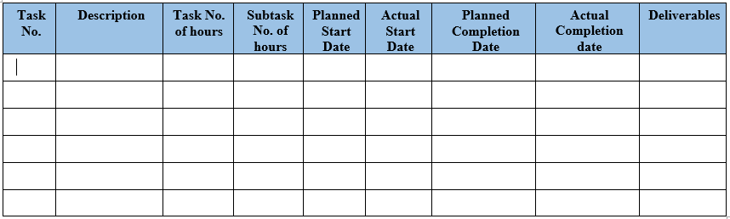

Page 12: Gantt chart
- You should convert the project TT into a Gantt chart and present as a figure
  - NB: Figures are identified uniquely and labelled at the foot of each figure
Page 13: References
Not less than 10 in APA Citation and Referencing Style

